Open access spin-off journal of JTEMB
Title “Journal of Trace Elements and Minerals” (JTEMIN),
Cover | Aims & scope
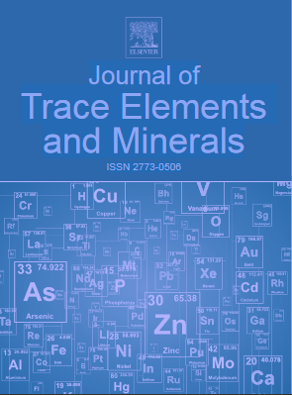 | The Journal of Trace Elements and Minerals (JTEMIN) is an online only, peer-reviewed, open access companion to Journal of Trace Elements in Medicine and Biology. It has a broader scope than the Journal of Trace Elements in Medicine and Biology and considers articles on all aspects of trace elements, trace element species and minerals in the widest sense. JTEMIN aims to publish high quality, evidence-based, original research articles, authoritative reviews in areas of special interest as well as preliminary studies, short communications, clinical and technical notes including analytical methods, biochemistry, pathobiochemistry of metabolic processes, molecular biology, nutrition, toxicology, environmental toxicology, epidemiology, clinical applications in diagnosis, therapy, food chain and veterinary medicine. JTEMIN is interdisciplinary and bring together different approaches for a diverse readership.
Dr. Rachel Ann Hauser-Davis from Oswaldo Cruz Foundation, Rio de Janeiro, Brazil is the Editor-in-Chief of the Journal of Trace Elements and Minerals.
A close cooperation between JTEMB and its open access spin-off is expected. On one hand we would like to offer an article transfers for manuscripts which are rejected in JTEMB, for example if these articles have a good quality but novelty is missing. On the other hand we would like to promote a direct submission coming from the community. For all transferred articles and all incoming direct submissions we will waive the article publication charge in the journals first year 2022.
Now we are contacting potential editorial board members. Please feel free to contact Dr. Silke Guddat (she/her), Senior Publisher, Journals, ELSEVIER, Phone: +49 174 344 22 73, E-mail: s.guddat@elsevier.com if you are interested to participate to the editorial board of JTEMIN. You are very welcome to our new editorial board. Please also feel free to share the information within your network or send me your recommendations who could be interested to join to the board.
Over the next weeks we need to work to set up a journal homepage as well as to implement the online submission system for JTEMIN.

